SCENARIO

You are an electrical technician in an electronics factory. Your supervisor asked you to work on solving some practical issues in different types of circuits that you are used in the products. Try to use your knowledge about circuit theory and transformation techniques to simplify and solve those problems.

To achieve the assessment criteria for pass (P1.2 part 2/2) you must answer the following task:

Task 1:
A)
Transmitter Signal
Internal Impedance
Load

A certain type of transmitters is produced in your factory with:
- Signal source E = 120 V.
- Internal impedance of 10 + j 10 Ω
The load that to be connected to the transmitter may be:
- An antenna as a pure resistive load = R.
- Direct TV receiver with complex impedance Z = R + j X.
For both cases apply circuit theory technique to solve such a problem to get the maximum power transferred to the load.

B)

- Using suitable software package, verify the superposition theorem in the circuit below. To measure the value V_{R1}, V_{R2}. Adjust the value of input sources i_{s}(t) = , vs(t) then value resistance R1= Ω ,
R2= Ω and R3= Ω
Then verify your answer using analytically method

To achieve the assessment criteria for pass (P1.4 part 2/2) you must answer the following task:

Task 2:
A band reject filter is a circuit used in many applications to stop certain frequency from passing to the next stage, one application is the ECG (Electro Cardio Gram). A band reject filter designed with parallel LR-C network as shown in the following figure.
- Draw the circuit below in your simulator software.
- If R= 20 Ω , L = 12 mH and C= 300 nF determine using your simulation the resonant frequency.
  - Put supply 60 V.
  - Change the frequency of the source from 500 Hz to 5 kHz (Step 250 Hz).
  - Measure the supply current each time.
  - Put your results into a table like:
f
i

  - Plot I versus f, then according to this relation determine the fr.
- Determine dynamic resistance.
- Determine the quality factor.
- Determine the band width.
- Comment on the filter selectivity.
To achieve the assessment criteria for pass (P1.3) you must answer the following task:

Task 3:
- Analyze the operation of a transformer as a magnetically coupled circuit. The transformer has 600 primary turns and 150 secondary turns. The primary and the secondary resistances are 0.25Ω and 0.01 Ω respectively and the corresponding reactance is 1.0Ω for the primary and 0.04Ω for the secondary, then determine the equivalent:
- Resistance.
- Reactance.
- The equivalent impedance referred to the primary winding.

- Two mutually coupled coils X and Y are connected in series to a 240 V supply as the following figure. Coil X has a resistance of 10 Ω and an inductance of 1.2 H. Coil Y has a resistance of 15 Ω and an inductance of 3 H. At a certain instant after the circuit is connected, the current is 5 A and increasing at a rate of 10 A/s.
- Analyze the operation of this magnetically coupled circuit.
- Determine:
- The mutual inductance between the coils.
- The coefficient of coupling.

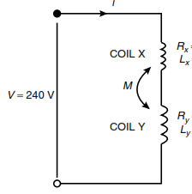
- A mutual inductor is used to couple a 20 Ω resistive load to a 50 V generator as shown in the following figure. The supply frequency is 75/π Hz.
- Analyze the operation of the circuit.
- Simulate the circuit to find i1 and i2.

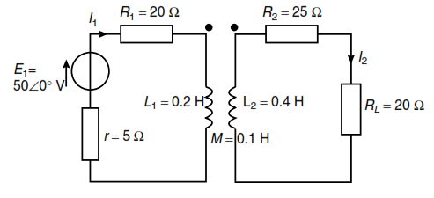

To achieve the assessment criteria for Merit (M1.2) you must answer the following task:

Task 4:
- In the following circuit find:
- The current in 10mH coil.
- The voltage drop across 1 kΩ resistor.
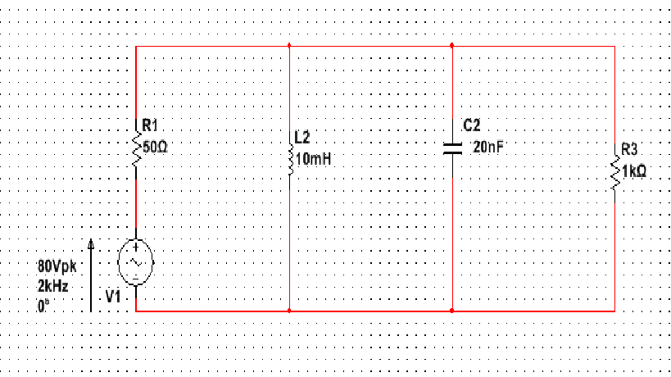
B) In the following circuit find:
- The current of each branch.
- The voltage drop across each component in the circuit.
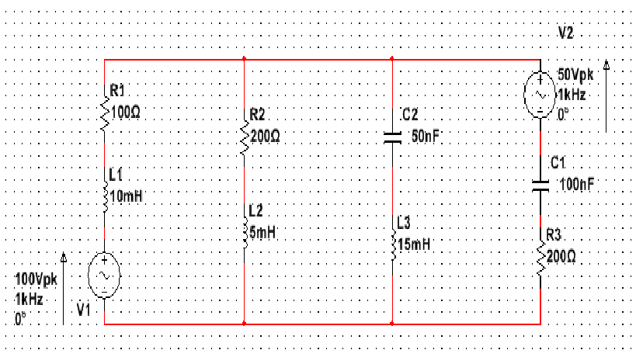
To achieve the assessment criteria for Merit (M2.1) you must answer the following task:

Task 5:
Show that the above circuit of task 4(B) can be solved by more than one theory.
To achieve the assessment criteria for Distinction (D1.2) you must answer the following task:

Task 6:
Simulate the circuit shown in task 4(B) and validate the results by comparing the simulated one by the calculated results in task 4(B).

